No. of Pages | 4
No. of Questions | 8

Department of Computer Science and Engineering
FINAL EXAMINATION FALL 2009

CSE320: Data Communications
Total Marks: 90 Time Allowed: 3 Hours

- Answer Any Six (6) questions out of Eight (8) questions.
- Figure in bracket [] next to each question indicates marks for that question.

Question No. 1

  - Compare the OSI and TCP/IP model by drawing the models. Also give examples of protocols for each layer of the TCP/IP Model. [3 marks]
  - In the OSI protocol architecture, state some functions of the physical layer? [2 marks]
  - Will DHCP make the management of BRAC University network more efficient, explain? [3 marks]
  - After you write www.bracu.ac.bd in the web browser URL box and press enter, which protocols help you view the contents of the web page of bracu? [4 marks]
  - Match appropriate protocols with the following statements: [3 marks]
- Used when you receive an email from your email server.
- Uses two separate connections to upload files to a server.
- Remote access to any device to control the device.
- Helps send emails from servers to servers.
- Used when you insert your username and password in a web page and they are sent to be verified for you to access the web page content.
- Resolves domain names to IP addresses

Question No. 2

- Name and explain three fields that exist in TCP header but not in UDP header? [4.5 marks]
- The source host sends segments with sequence numbers 3000 to 4499 in segments of 500 bytes. The segments with numbers 3000 to 3499 all arrive safely but the others were dropped due to congestion on the destination side. How will the destination host notify the sender of the congestion? [3.5 marks]
- Port numbers included in the TCP header of a segment, why? In FTP there are two port numbers, why? [4 marks]
- What is a Three Way Handshake? [3 marks]

Question No. 3

- State and explain briefly two characteristics of IPv4 the network layer protocol. [3 marks]
- A workstation is configured as follows. But it is unable to connect to the Internet? What can be the problem? [3 marks]
IP address: 172.16.3.127
Subnet mask: 255.255.255.0
Default gateway: 172.17.3.1

- What is the purpose of loopback IP address? [3 marks]

Gateway of last resort is 192.168.2.2 to network 0.0.0.0
10.0.0.0/24 is subnetted, 2 subnets
R10.1.1.0[120/1]via 192.168.2.2,00:00:02,serial0/0
R10.1.2.0[120/1]via 192.168.2.2,00:00:02,serial0/0
C192.168.2.0/24 is directly connected, serial 0/0
C192.168.1.0/24 is directly connected, FastEthernet0/0
C192.168.3.0/24 is directly connected, FastEthernet0/1

Figure No. 1
- Refer to the above figure no.1 which represents the routing table of a router; the router receives a packet destined for 10.2.1.0 network. After consulting the routing table, what shall the router do? Explain. [3 marks]
- How are dynamic routes learnt by routers? [3 marks]

Question No. 4

- You are required to set up a network in an organization where the distance between equipments is more than 500 meters and they are exposed to a lot of electrical interferences, which type of cable would meet all of these requirements and why? [3 marks]
- 100BASETX uses what type of cable? State how this type of cable reduces inferences from outside sources. [4 marks]
- In multimode fiber optic cable, there is more dispersion in the output light wave than single mode fiber optic cable, why? [3 marks]
- Compare the physical structure of optical fiber and coaxial cable, use diagrams. Which components are used for reducing electromagnetic interference? [5 marks]

Question No. 5

Preamble | SFD | Address | Address | Length/Type | Data and padding | FCS

Figure No. 2

- The above figure no. 2 represents an Ethernet frame. When do we need to pad our data part in the Ethernet frame with extra redundant bits and why? [4 marks]
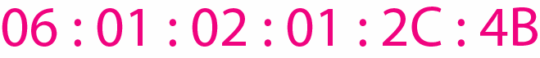
- What do the above numbers represent? Write a short note on it. Also describe the different types available. [5 marks]
- What are the available topology types in a LAN? [3 marks]
- Compare 100BASEFX and 10BASE2. [3 marks]

Question No. 6

- Explain what is meant by 'random' and 'controlled access' in the context of MAC protocols. [3 marks]
- Can all stations in Reservation access method send frames simultaneously, explain your answer? [4 marks]
- Explain the difference between SELECT and POLL packets in Polling. [4 marks]

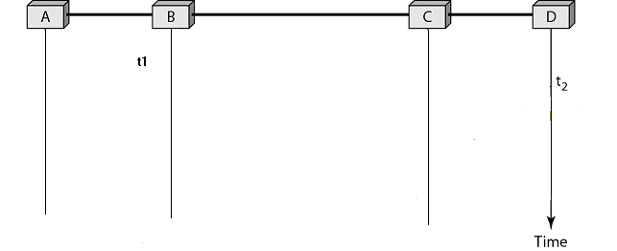
Figure No. 3
- The above diagram (figure no. 3) shows host B started transmitting at time t1=0, and host D at time t2=5 μsec using CSMA /CD. Complete the diagram (provided in a separate sheet) to show, where does the collision occur? When will Host B know about the collision and what does Host B after detected collision? [4 marks]

Question No. 7

- What is windowing in flow control techniques? Does it make data transmission efficient, why? [3 marks]
- How do REJ supervisory frames help in Go-Back N ARQ? [4 marks]

- In HDLC protocol, frames have flags to indicate the start and end of the frame. A receive can interpret a part of data as flag and end the frame incorrectly, how do we solve this?[3 marks]
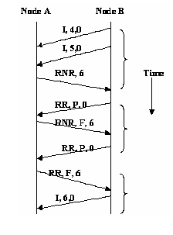
Figure No. 4
Step 1
Step 2
Step 3
- Referring to figure no. 4 above, explain in three steps what is happening? What do the letters P and F refer to? [5 marks]

Question No. 8

- Encode the following data stream 11100011 using Differential Manchester and NRZ-I. Use the separate sheet provided. [4 marks]
- 100BASE-FX Ethernet uses 4B/5B coding and then NRZ-I encoding. Explain what is the purpose of and the steps involved in 4B/5B coding before using NRZ-I. [5 marks]
- What is the disadvantage of NRZ-I technique when compared with Manchester encoding, explain briefly. [3 marks]
- The receiver’s bit intervals must correspond exactly to the senders bit intervals. Why? [3 marks]

THE END

